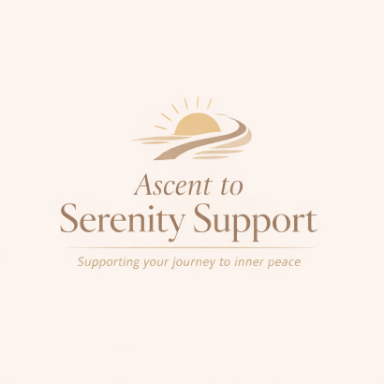
Ascent to Serenity Support

Client Agreement

Service Overview
Ascent to Serenity Support provides emotional support and guidance. This service is not a substitute for counselling, psychotherapy, or medical advice.

Eligibility
This service is strictly for individuals aged 18 and over.

Sessions
Sessions last approximately 50 minutes and are conducted online unless otherwise agreed.

Commitment
Clients are expected to commit to a minimum of 4 sessions and a maximum of 12 sessions unless otherwise agreed.

Fees & Payment
Payment must be made in advance of each session or as part of a pre-agreed package.

Cancellations
A minimum of 24 hours’ notice is required for cancellations. Late cancellations or missed sessions may be charged in full.

Boundaries
A professional, respectful relationship will be maintained at all times. This service does not engage in crisis intervention.

Liability
Ascent to Serenity Support accepts no liability for decisions made by clients based on sessions provided.

Signature:
Print Name:
Date:

